March Newsletter
Ms. Roth’s Classroom News
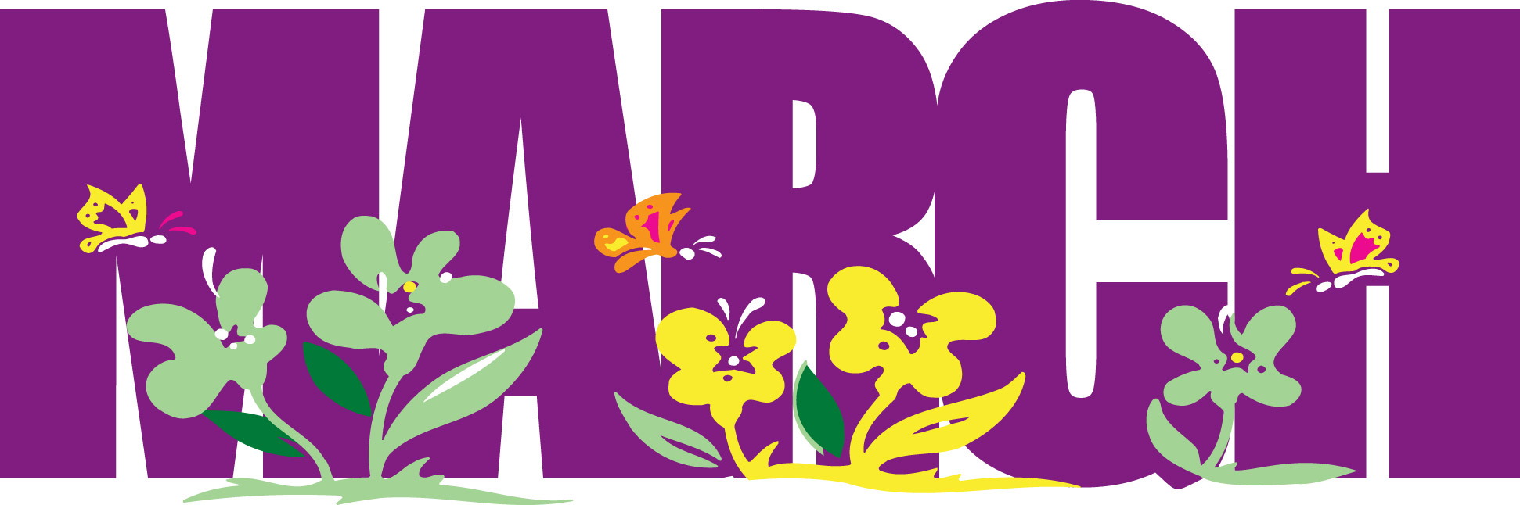

Upcoming Events

March 2
Read Across America Day

March 12

Book Fair Starts

March 21
Report Card Distribution
March 28
Youth Museum Field Trip (more details coming soon)

Homework is attached and is due on Friday.

Powers Ferry Elementary-4th Grade Room 212
Stacy.roth@cobbk12.org
Dear Parents,
This newsletter will serve as our monthly communication as to the “Happenings” inside our classroom, here at the school and outside in the community. The newsletter will also include overall learning topics in each subject area that we will be covered during the month.
I hope everyone had a great break! Thank you so much for all of the Valentine’s cards and candy!!
During three weeks in March we will be rotating classes in order to maximize our standards review for Milestones Testing. This process worked great last year in our fourth grade classes.
Please remember my door is always open with concerns or questions. I am here to help.
Thanks!
Ms. Roth

Math: Students will be focusing on the following area:
*Fractions and Geometric Principals
Reading: Elements of poetry.
Writing: Informational and Creative Writing.
Social Studies: The Early Republic and a Growing Country Science: The Solar System

